32.AIM:-  To draw the uml diagram for jewel loan management system using umbrello.

STATE CHART DIAGRAM:

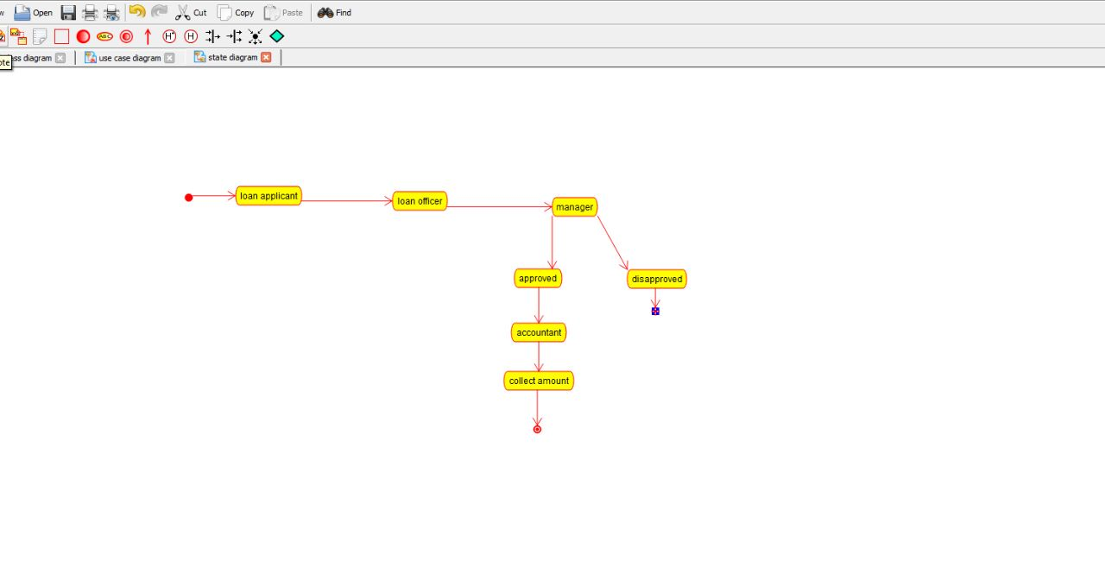

USE CASE DIAGRAM:

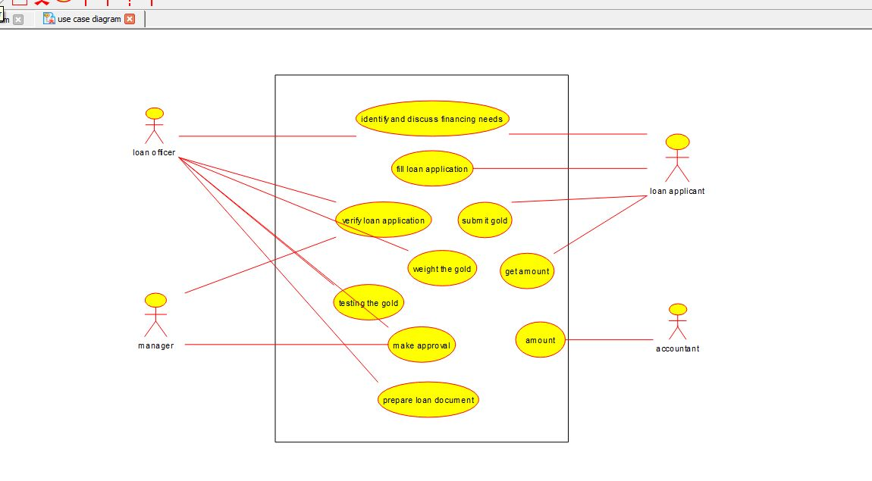

COLLABORATION DIAGRAM:

